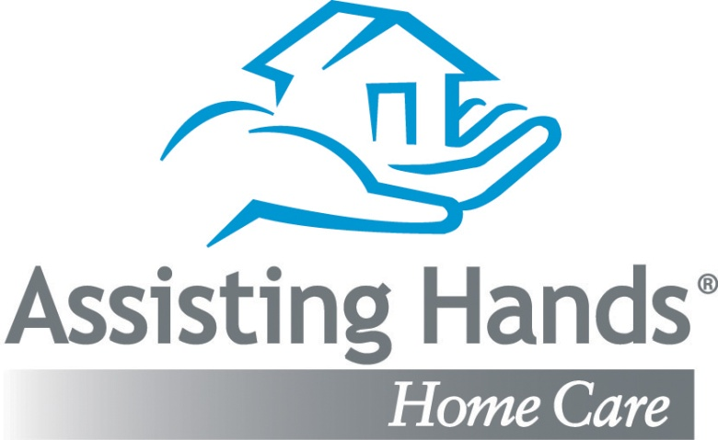

Telephony Number/ Clock In
888-401-4109

Portal / Internet Clock In (Must Have Location on)
app.clearcareonline.com Password: assist

Office Number
630-305-9100

After Hours Line 5PM-9AM
630-322-9383
(Only to be called for Emergencies)

Important Emails:

Mpavone@assistinghands.com – Agency Manager
Kotero@assistinghands.com –Lead Care Manager/Scheduling
Sflom@assistinghands.com – Care Manager /Scheduling

Caregiver Recruitment Number
331-457-3390

